Section I: Scenario Demographics

Scenario Title: | Ethylene Glycol Overdose
Date of Development: | 02/04/2015 (DD/MM/YYYY)
Target Learning Group: | Juniors (PGY 1 – 2) Seniors (PGY ≥ 3) All Groups

Section II: Scenario Developers

Scenario Developer(s): | Kyla Caners
Affiliations/Institution(s): | McMaster University
Contact E-mail (optional): | kcaners@gmail.com

Section III: Curriculum Integration

Learning Goals & Objectives
Educational Goal: | To work through the differential diagnosis of a patient with an altered LOC and to learn how to respond to an unexpected anion gap metabolic acidosis.
CRM Objectives: | Effectively lead team through complex case.
Medical Objectives: | - Identify the complex differential diagnosis for altered LOC and initiate appropriate workup.  - Identify the need for airway protection in the severely altered patient and demonstrate a safe approach to intubating.  - Recognize the presence of severe acidosis with an anion gap and osmolar gap as possibly caused by toxic alcohols and initiate appropriate investigations/treatment.

Case Summary: Brief Summary of Case Progression and Major Events
46 year-old male presents with GCS 3 after being found in the back alley behind a drug store. The team will need to work through a broad differential diagnosis and recognize the need to intubate the patient. If they try naloxone, it will have no effect. After intubation, the team will receive critical VBG results showing a profound metabolic acidosis with a significant anion gap. The goal is to trigger the team to work through the possible causes of an elevated anion gap, including toxic alcohols.

References
Marx, J. A., Hockberger, R. S., Walls, R. M., & Adams, J. (2013). Rosen's emergency medicine: Concepts and clinical practice. St. Louis: Mosby.

Section IV: Scenario Script

A. Scenario Cast & Realism
Patient: | Computerized Mannequin |  |  |  |  | Realism:  Select most important dimension(s) |  |  | Conceptual
 | Mannequin |  |  |  |  |  |  |  | Physical
 | Standardized Patient |  |  |  |  |  |  |  | Emotional/Experiential
 | Hybrid |  |  |  |  |  |  |  | Other:
 | Task Trainer |  |  |  |  |  |  |  | N/A
Confederates | Brief Description of Role
Paramedic | Gives handover on patient, then leaves.
B. Required Monitors
EKG Leads/Wires |  |  | Temperature Probe |  |  |  | Central Venous Line
NIBP Cuff |  |  | Defibrillator Pads |  |  |  | Capnography
Pulse Oximeter |  |  | Arterial Line |  |  |  | Other:
C. Required Equipment
Gloves |  |  | Nasal Prongs |  |  |  | Scalpel
Stethoscope |  |  | Venturi Mask |  |  |  | Tube Thoracostomy Kit
Defibrillator |  |  | Non-Rebreather Mask on patient at start of case |  |  |  | Cricothyroidotomy Kit
IV Bags/Lines |  |  | Bag Valve Mask |  |  |  | Thoracotomy Kit
IV Push Medications |  |  | Laryngoscope |  |  |  | Central Line Kit
PO Tabs |  |  | Video Assisted Laryngoscope |  |  |  | Arterial Line Kit
Blood Products |  |  | ET Tubes |  |  |  | Other:
Intraosseous Set-up |  |  | LMA |  |  |  | Other:
D. Moulage
None required.
E. Approximate Timing
Set-Up: |  | 3 min |  | Scenario: | 12 min |  |  | Debriefing: |  | 15 min

Section V: Patient Data and Baseline State

A. Clinical Vignette: To Read Aloud at Beginning of Case
EMS has just brought you to a patient with a GCS of 3. He was found in the back alley behind a drug store with no identifying information. He is not known to EMS or to your department. He appears to be in his 30s or 40s.
B. Patient Profile and History
Patient Name: John Doe |  |  |  |  |  | Age: unknown |  |  |  |  |  |  |  | Weight: Approx 70kg.
Gender: M F |  |  |  |  |  | Code Status: unknown, presumed full code
Chief Complaint: altered LOC
History of Presenting Illness: Found in back alley behind a drug store with no identifying information and no bystanders. GCS 3.
Past Medical History: |  | Unknown. |  |  |  |  | Medications: |  |  |  |  | Unknown.
Allergies: Unknown.
Social History: Unknown.
Family History: Unknown.
Review of Systems: |  | CNS: |  |  | All ROS unknown.
 |  | HEENT:
 |  | CVS:
 |  | RESP:
 |  | GI:
 |  | GU:
 |  | MSK: |  |  |  |  |  |  |  |  |  |  | INT:
C. Baseline Simulator State and Physical Exam
No Monitor Display |  |  |  | Monitor On, no data displayed |  |  |  |  |  |  | Monitor on Standard Display
HR: 120/min |  |  | BP: 100/60 |  |  |  |  | RR: 30/min |  |  |  |  |  |  | O₂SAT: 96% NRB
Rhythm: Sinus tachy |  |  | T: 36ºC |  |  |  |  | Glucose: 6.4 mmol/L |  |  |  |  |  |  | GCS: 3 (E1 V1 M1)
General Status: Non-responsive.
CNS: | PERLA, 3 mm. GCS3.
HEENT: | No signs trauma.
CVS: | No murmur.
RESP: | GAEB. Very tachypneic.
ABDO: | Soft, NT.
GU: | Nil.
MSK: | No signs trauma. |  |  |  |  |  |  |  | SKIN: | No track marks.

Scenario States, Modifiers and Triggers
Patient State | Patient Status | Learner Actions, Modifiers & Triggers to Move to Next State
1. Baseline State  Rhythm: Sinus tach  HR: 120/min  BP: 100/60  RR: 30/min  O₂SAT: 96% NRB  T: 36ºC | Comatose. Completely unresponsive with GCS 3. | Learner Actions  - IV, O2, monitors  - Check cap sugar (6.4)  - Order broad blood work  - ECG  - IV NS 1L bolus  - May try narcan (0.04mg)  - Prepare for intubation  - Acknowledge eventual need for CT head | Modifiers  Changes to patient condition based on learner action  - Narcan tried No response  - ECG requested Give ECG  Triggers  For progression to next state  - Intubation 2. Intubation  - 6 min 3. VBG back
2. Intubation  (as above) | Patient remains unresponsive. | Learner Actions  - Administer induction  - Administer paralytic | Modifiers  - Paralytic given RR 0 until intubated (then RR 24 vented)  - Sedation given BP 94/58  Triggers  - Successful intubation  3. VBG back
3. VBG back  If intubated:  HR 110  BP 94/58  RR 24 (vented)  O2 99%  If not intubated:  - Vitals unchanged from baseline state. | Patient either intubated or still in same state as at baseline.  Give labs to team at onset of state. | Learner Actions  - Recognize anion gap & osmolar gap  - Order toxic alcohols  - Call Poison Center  - Call Nephrology  - Empirically administer fomepizole 15mg/kg iv load  - Administer thiamine 100mg iv, pyridoxine 50mg iv, and folate 50mg iv | Modifiers  - 10 minutes police call saying empty bottle antifreeze found behind drug store  - Poison center/Tox called advise re: fomepizole, co-factors  Triggers  - Fomepizole given 4.Resolution  - 12 minutes 4. Resolution
4. Resolution  Vitals unchanged from previous state. | Patient either intubated or still in same state as at baseline. | Learner Actions  - Call Nephrology  - Call ICU  - May intubate if still haven’t | ICU or Nephrology arrive  END CASE
Section VI: Scenario Progression

Section VII: Supporting Documents, Laboratory Results, & Multimedia

Laboratory Results
Na: 140 | K: 3.7 |  |  | Cl: 105 |  | HCO₃: 10 |  | BUN: 8 |  | Cr: 98 |  |  | Glu: 6
Anion gap: 25
VBG |  | pH: 7.10 |  |  | PCO₂: 22 |  | PO₂: 45 |  | HCO₃: 10 |  |  | Lactate: 4
WBC: 13.1 |  |  | Hg: 136 |  |  |  | Hct: 0.43 |  |  |  | Plt: 456
Osmol: 339 |  |  | EtOH: <2 |  |  |  | ASA: neg |  |  |  | APA: neg

Images (ECGs, CXRs, etc.)
ECG: sinus tachycardia  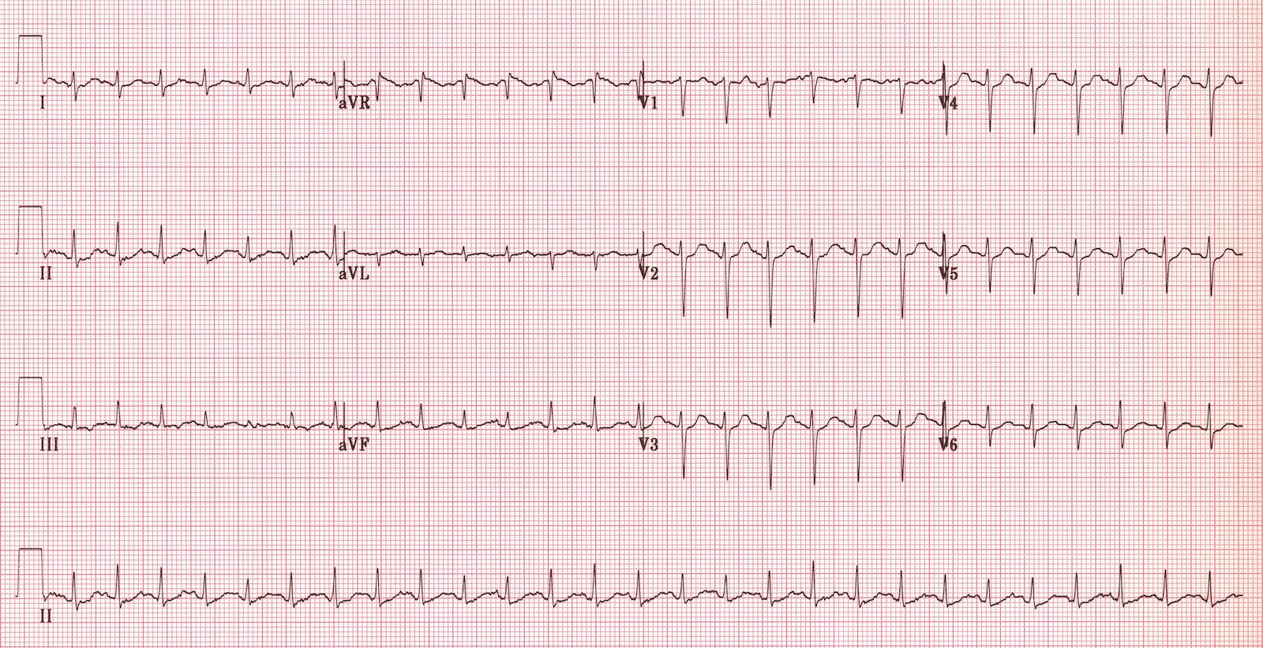  (ECG source: http://i0.wp.com/lifeinthefastlane.com/wp-content/uploads/2011/12/sinus-tachycardia.jpg) | CXR: post-intubation  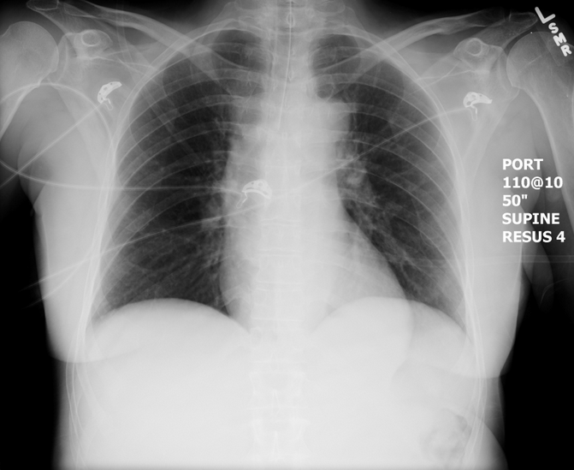  (CXR source: https://emcow.files.wordpress.com/2012/11/normal-intubation2.jpg)

Section VIII: Debriefing Guide

General Debriefing Plan
Individual | Group |  | With Video | Without Video
Objectives
Educational Goal: |  | To work through the differential diagnosis of a patient with an altered LOC and to learn how to respond to an unexpected anion gap metabolic acidosis.
CRM Objectives: |  | Effectively lead team through complex case.
Medical Objectives: |  | - Identify the complex differential diagnosis for altered LOC and initiate appropriate workup.  - Identify the need for airway protection in the severely altered patient and demonstrate a safe approach to intubating.  - Recognize the presence of severe acidosis with an anion gap and osmolar gap as possibly caused by toxic alcohols and initiate appropriate investigations/treatment.
Sample Questions for Debriefing
- What is your differential diagnosis for a severely altered patient and what is your approach to working through that differential?
- What are the causes of an increased anion gap metabolic acidosis?
- What treatments are indicated for the management of a toxic alcohol ingestion? How do you initiate them? What would you do if you were uncertain whether to start the treatments?
Key Moments
Initial attempts at improving LOC (narcan, cap sugar acknowledged)
Identification of need to protect airway
Recognition of increased anion gap metabolic acidosis and possible causes

